Ruth West Arts 203 Fall 2017

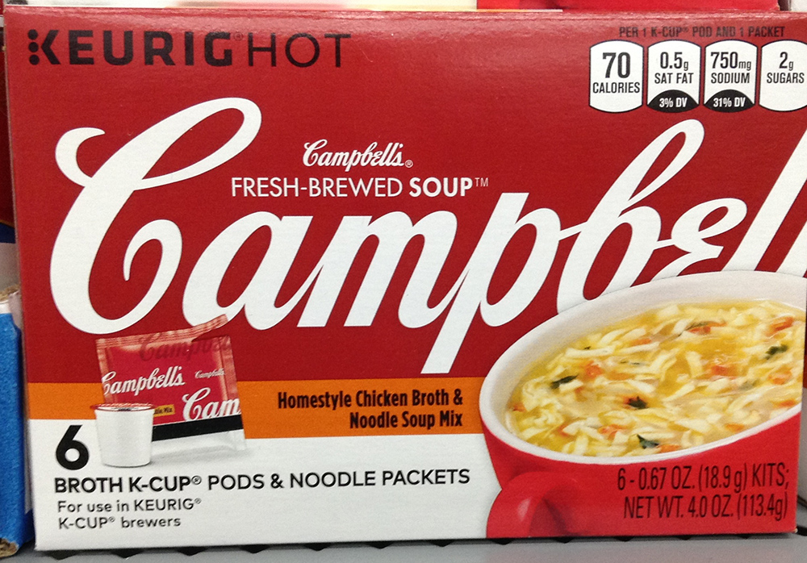

Cambells Soup Box

This box is designed to make you feel how warm and delicious Cambells soup is. The color scheme of red- denotes warmth with the cup ( done in logo red) tipping towards the mouth. The font-logo lead the eye to the soup but goes behind the soup pushing the cup forward.

The Cambells font is italized which makes it feel more handwritten and therefore "homemade". The two words above Cambells logo, Cambells and fresh brewed soup are tightly leaded and nestled in the logo. "FRESH-BREWED" is sans serif and capped while the word soup is bold to draw your eye.

Different sections of the packaging words, are different sizes and weights to draw you eye to them or minimize them. The 6 OZ , NET 4OZ, are done black on red ( harder to read), All Cap ( harder to read), ( Thin, tightly Kerned (harder to read), and in the lower right corner , the last place the viewer reads. This makes that phasing almost invisible. The calories, sodium etc. in the upper right corner doesn’t draw the eye- unless the viewer is looking for it.

